RECYCLING PICKUP SCHEDULER SYSTEM USER INTERFACE MOCKUP

1.USE CASE DIAGRAM
Based on the Use-case diagram, we have the mockup for our web function:
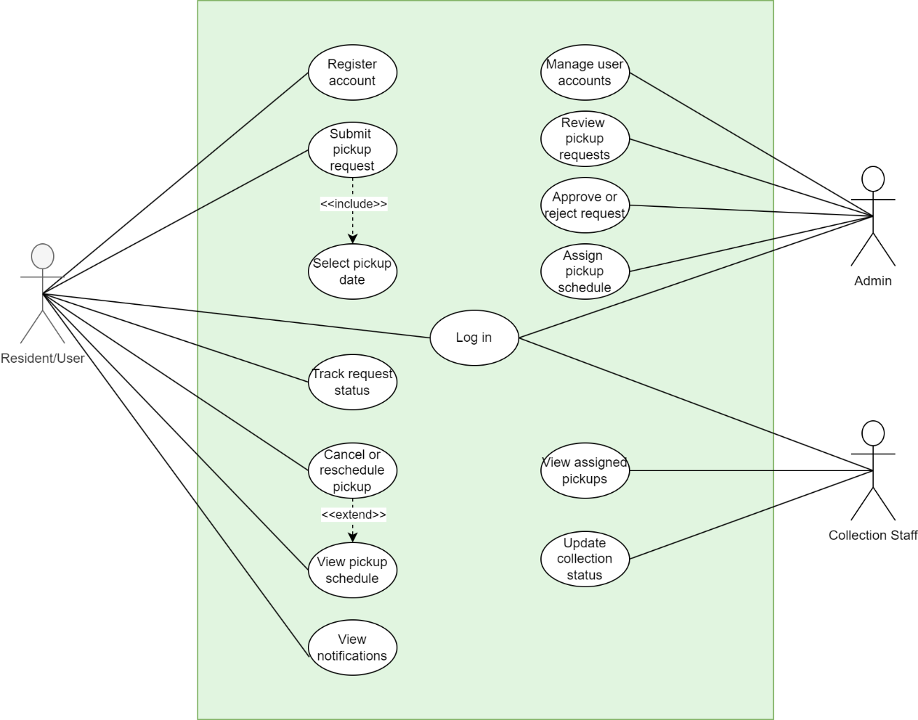
Recycling Pickup Scheduler Usecase diagram
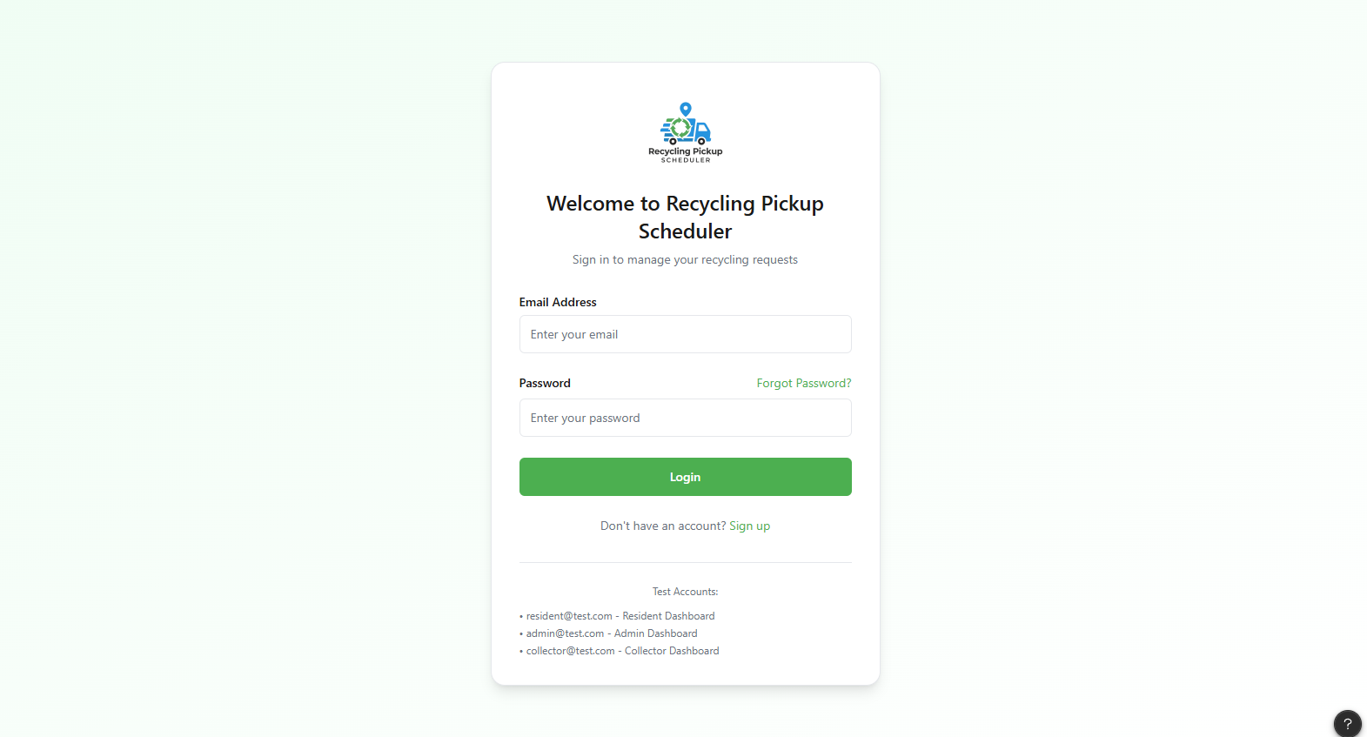
Default login page

2. RESIDENT USER INTERFACE – PAGE FUNCTIONS

Dashboard Page

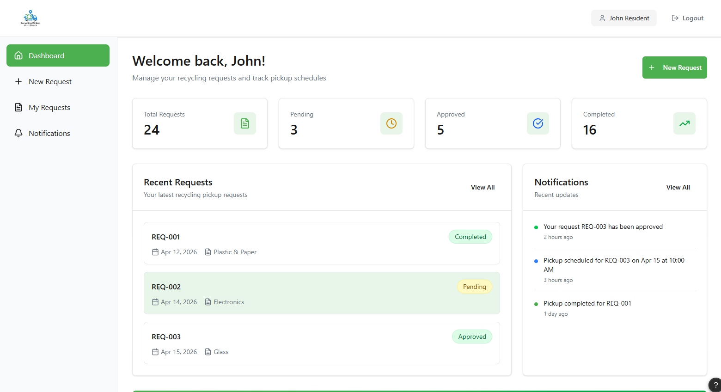
Purpose: Overview and quick access
Functions:
- View request summary (total, pending, approved, completed)
- View recent requests
- Access “New Request” quickly
- Preview notifications
- Navigate to other pages
Use Case: Track request status

2.My Requests Page

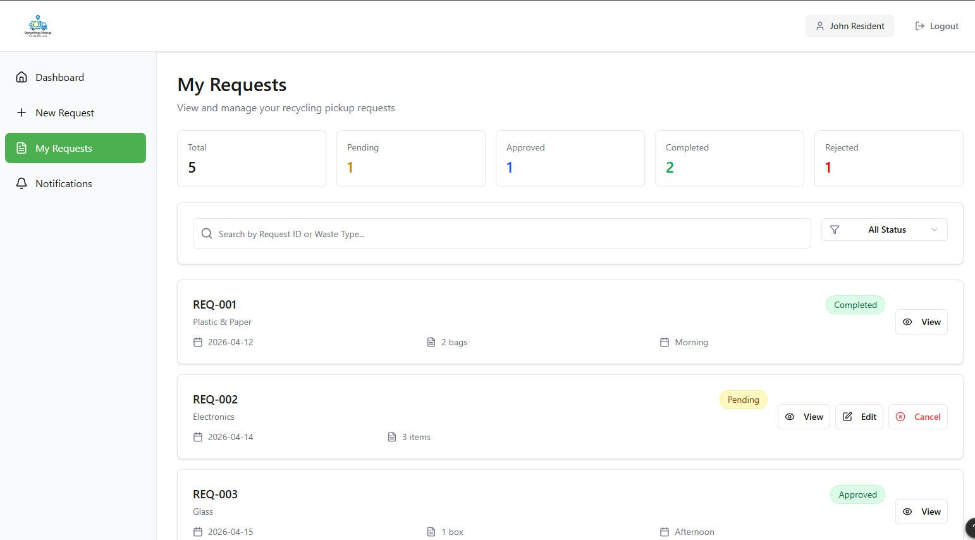
Purpose: Manage all requests
Functions:
- View all requests with details and status
- Search and filter requests
- View request details
- Edit or cancel requests (if pending)
Use Case: View, cancel, reschedule requests

3.Submit Request Page

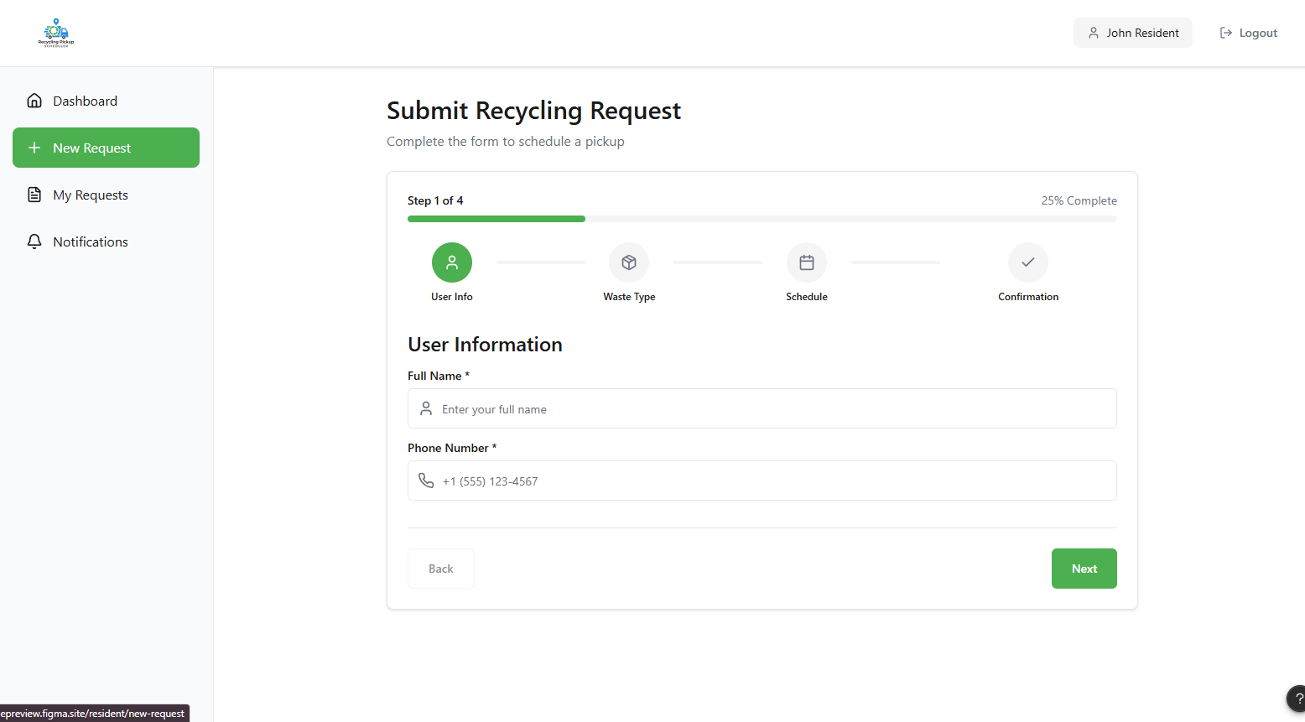
Purpose: Create new request
Functions:
- Enter user information
- Select waste type
- Choose pickup date/time
- Confirm and submit request
Use Case: Submit request, select pickup date

4.Notifications Page

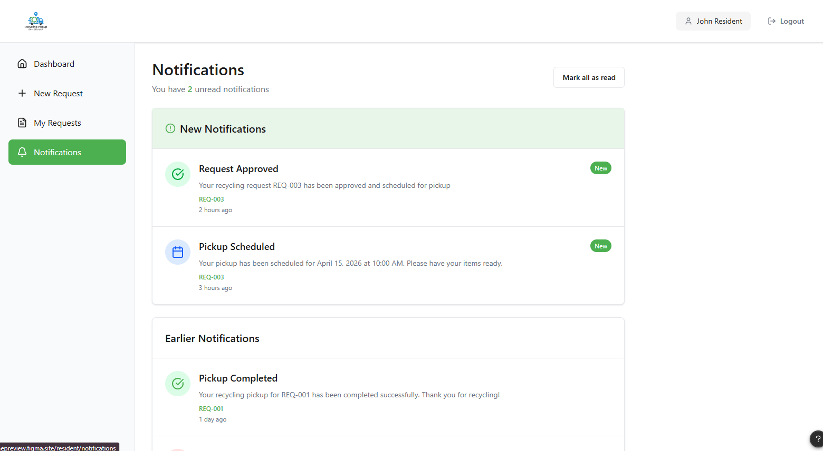
Purpose: View system updates
Functions:
- View new and past notifications
- Track request updates (approved, scheduled, completed)
- Mark notifications as read
Use Case: View notifications

3.ADMIN USER INTERFACE – PAGE FUNCTIONS

1.Dashboard Page

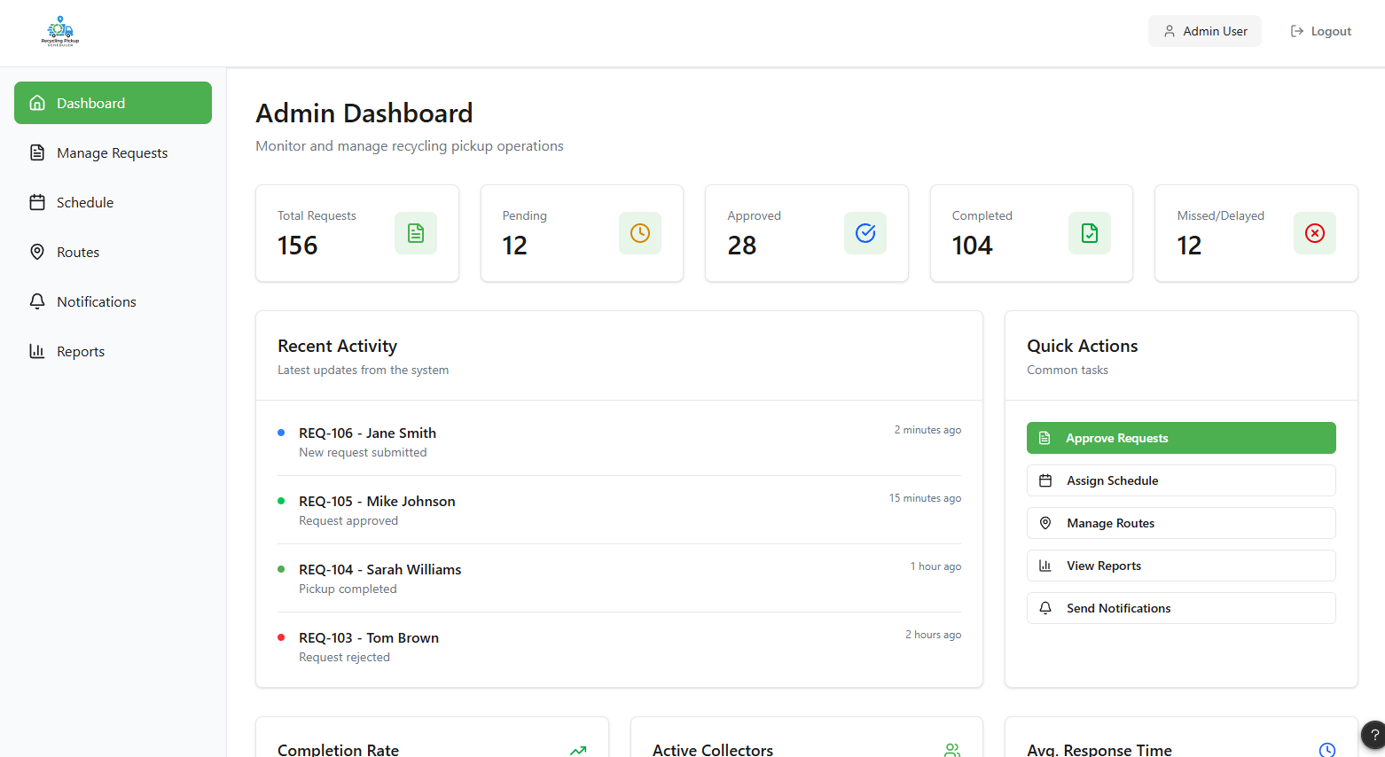
Purpose: Monitor overall system performance
Functions:
- View system summary (total, pending, approved, completed, missed)
- View recent activities (new requests, approvals, completions)
- Access quick actions (approve requests, assign schedule, manage routes, view reports, send notifications)
- Navigate to all admin features
Use Case: Review pickup requests, manage system

2.Manage Requests Page

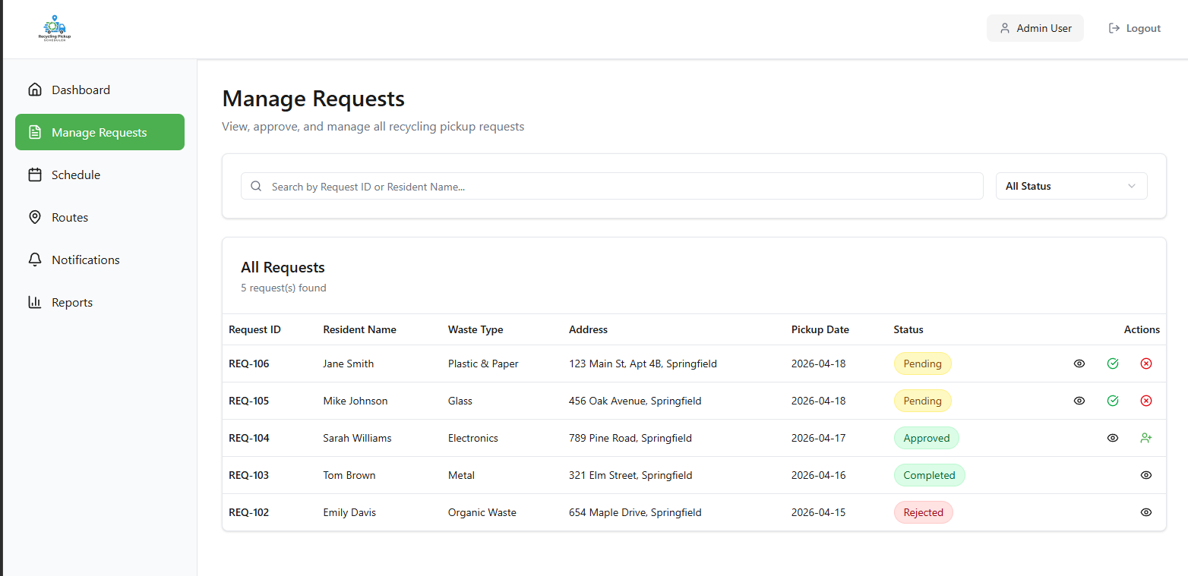
Purpose: Review and control all pickup requests
Functions:
- View all requests with full details
- Search and filter requests
- View request details
- Approve or reject requests
- Assign collector (after approval)
Use Case: Review pickup requests, approve or reject request

3.Schedule Management Page

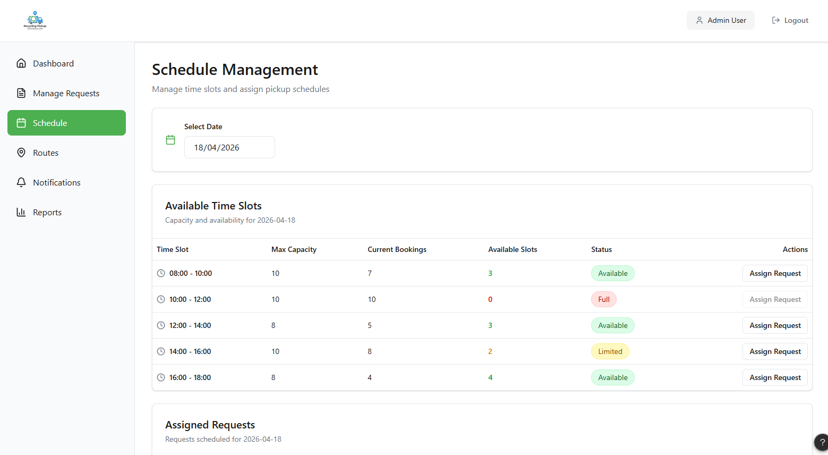
Purpose: Manage pickup time slots and scheduling
Functions:
- View available time slots and capacity
- Monitor current bookings and availability
- Assign requests to time slots
- Manage scheduling conflicts
Use Case: Assign pickup schedule

4.Route Assignment Page

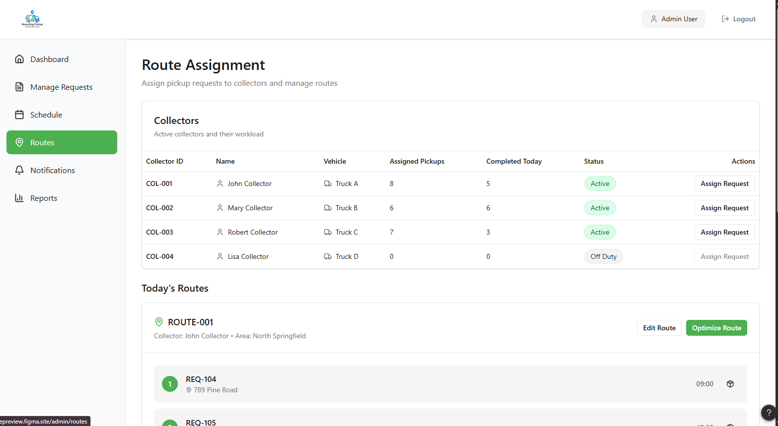
Purpose: Assign and optimize collection routes
Functions:
- View collectors and their workload
- Assign pickup requests to collectors
- View and manage routes
- Optimize routes for efficiency
Use Case: Assign pickup schedule (execution level)

5.Reports & Analytics Page

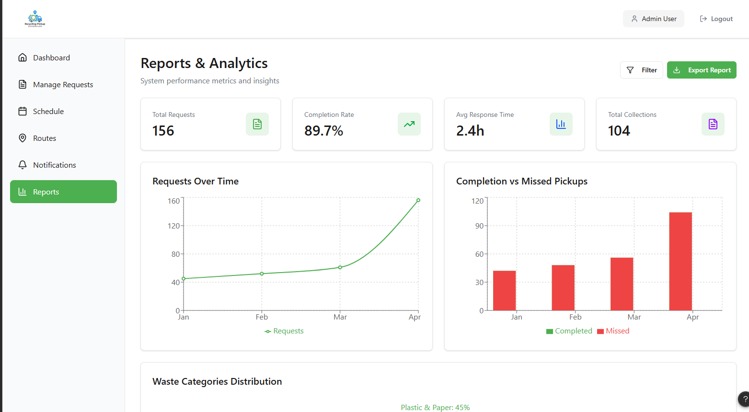
Purpose: Analyze system performance
Functions:
- View key metrics (total requests, completion rate, response time)
- Analyze trends (requests over time, completed vs missed)
- Filter data
- Export reports
Use Case: Monitor system operations

6.Notification Management Page

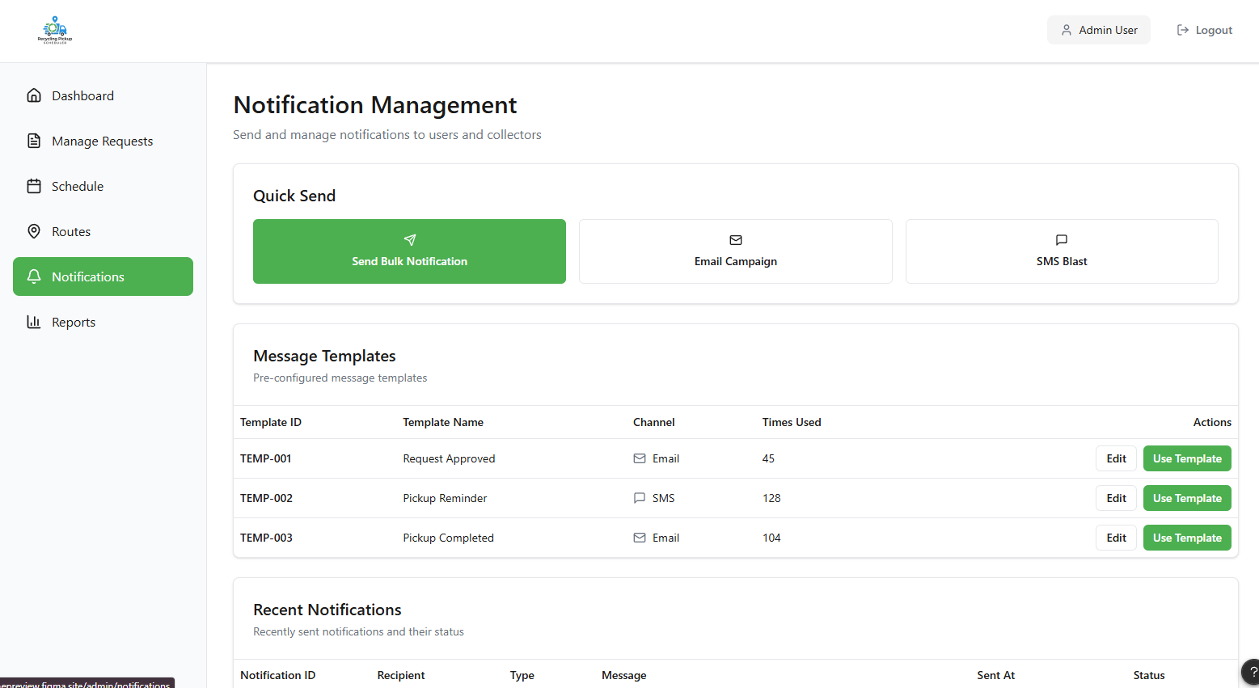
Purpose: Send and manage system notifications
Functions:
- Send bulk notifications to users and collectors
- Send notifications via different channels (email, SMS)
- Use and edit message templates
- View recent notifications and their status
- Track delivery (sent, pending, failed)
Use Case: Send notifications

4.COLLECTOR USER INTERFACE – PAGE FUNCTIONS

1.Dashboard Page

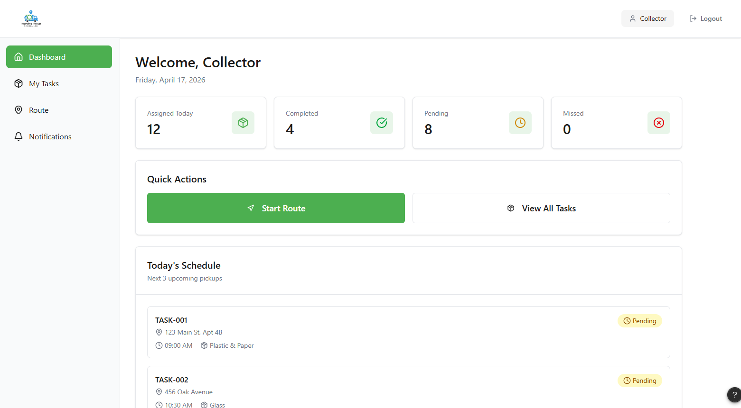
Purpose: Overview of daily tasks
Functions:
- View total assigned, pending, completed, and missed tasks
- View today’s pickup schedule
- Quick access to start route and view tasks
Use Case: View assigned pickups

2.My Tasks Page

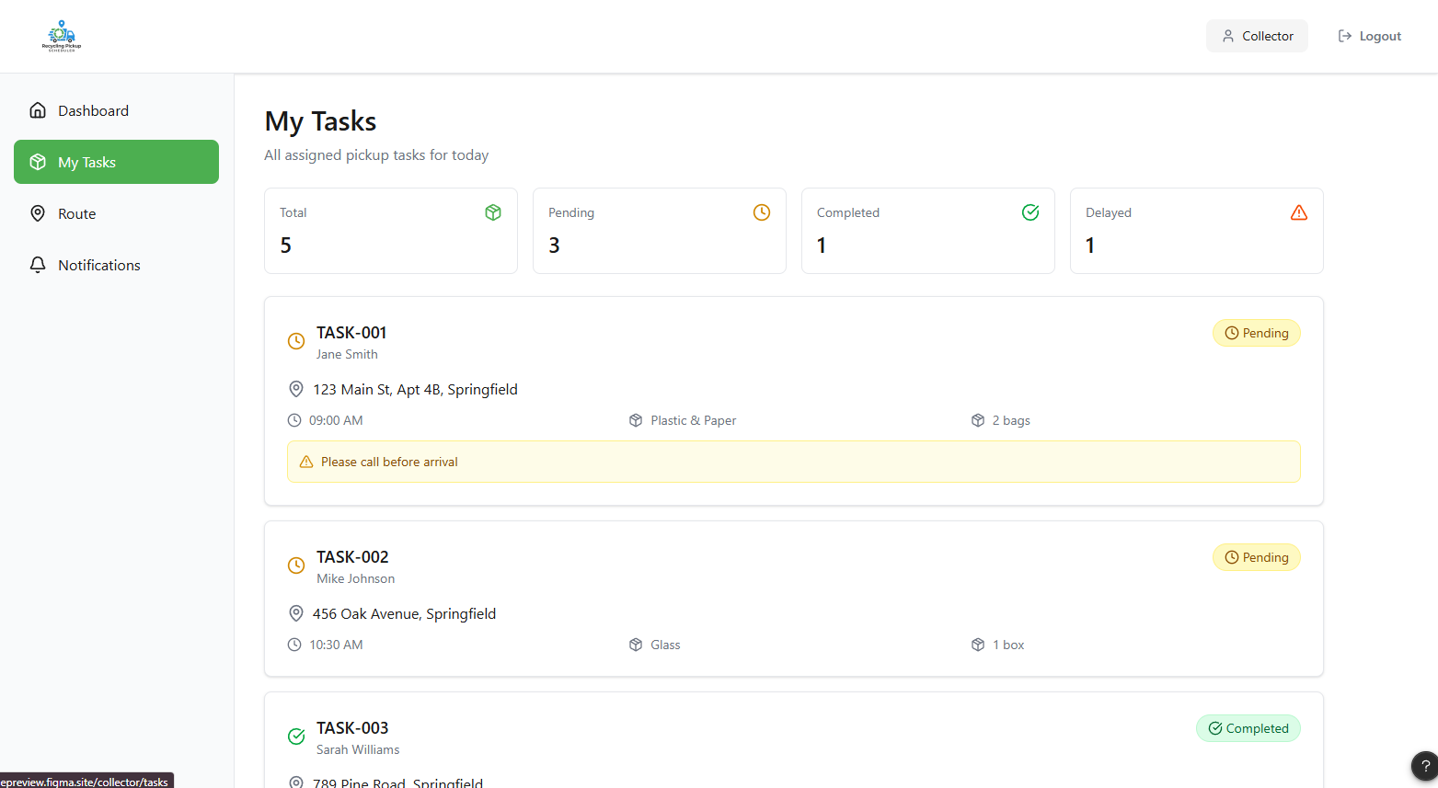
Purpose: Manage assigned pickup tasks
Functions:
- View all assigned tasks with details (address, time, waste type)
- Track task status (pending, completed, delayed)
- Update task status (mark as completed or delayed)
- View special notes or instructions
Use Case: View assigned pickups, Update collection status

3.Route Page

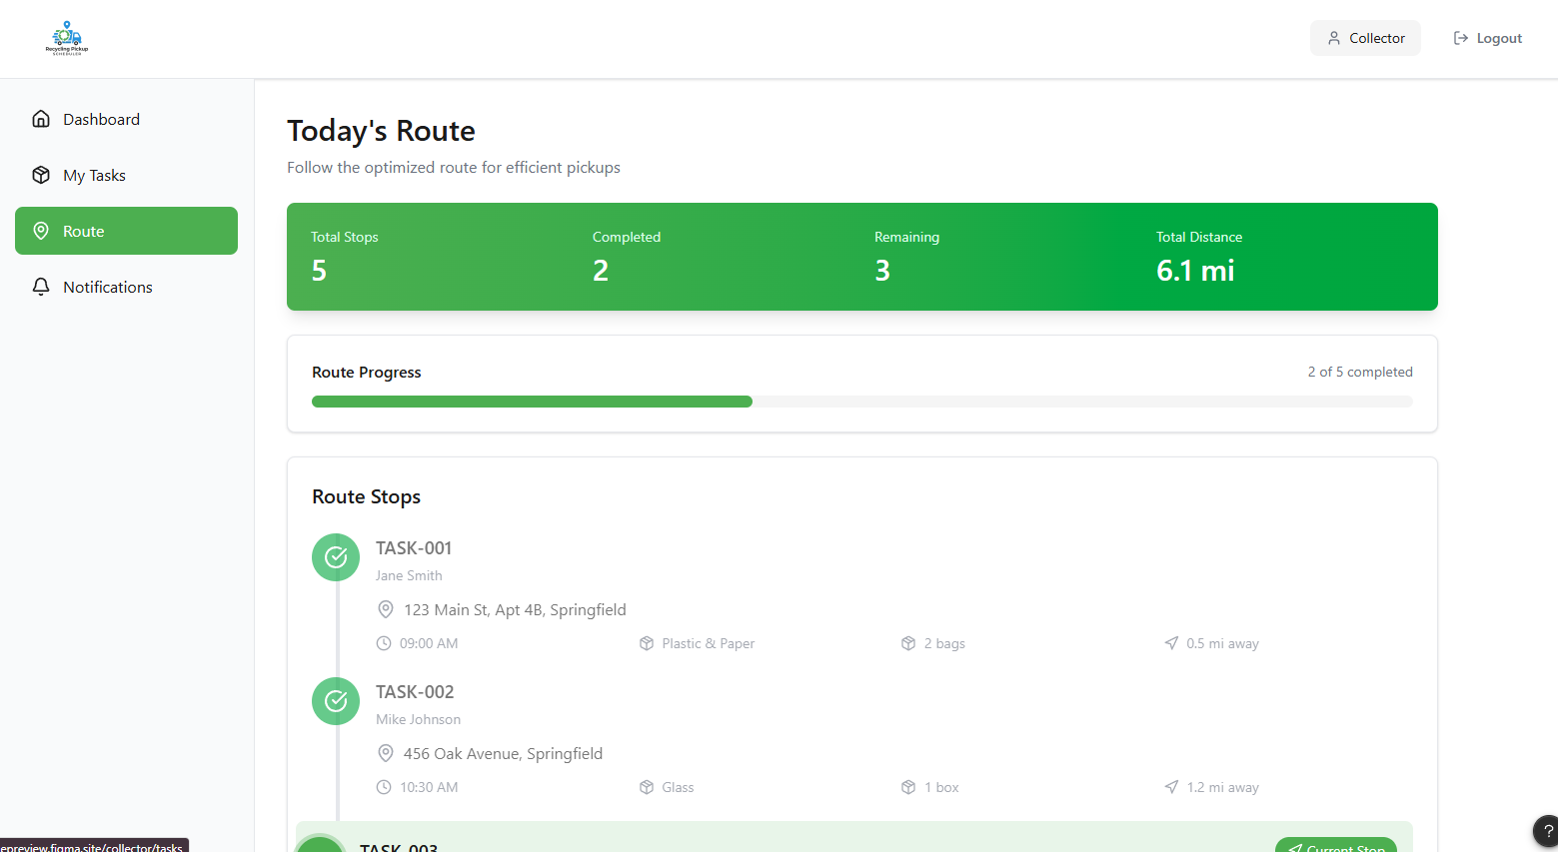
Purpose: Follow and manage pickup route
Functions:
- View optimized route and stops
- Track route progress (completed vs remaining)
- View details of each stop
- Navigate through pickup sequence
Use Case: View assigned pickups

4.Notifications Page

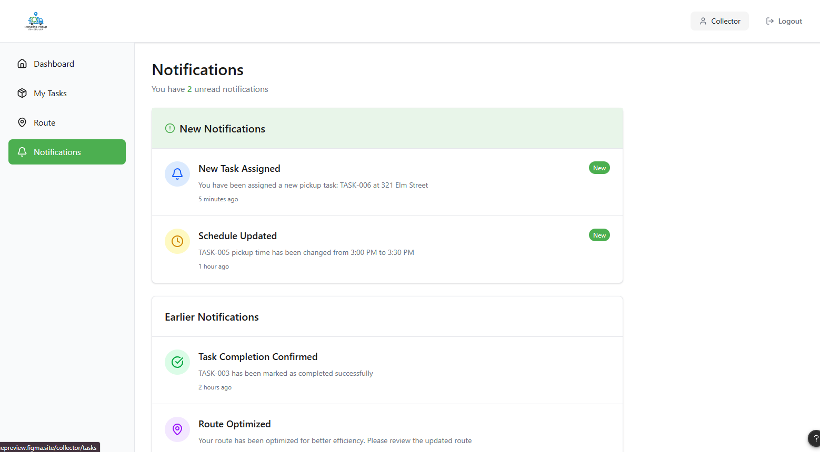
Purpose: Receive system updates
Functions:
- View new task assignments
- Receive schedule updates
- Get route changes and confirmations
- Track notification history
Use Case: Receive notifications

